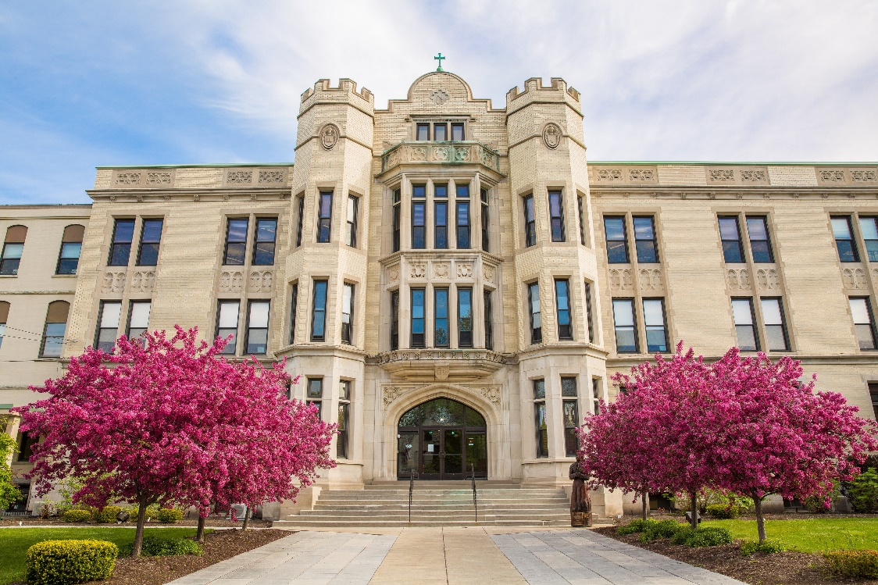

MINIMUM CAPACITY :-

The Minumum intake capacity

of students is between 310-450

children

LIBRARY :-

The Libarary is Available.

CANTEEN:-

The Canteen Facility is Available.

BOARDING :-

No availablility of boarding.

SPORTS :-

There are different categories

sports available.

Girls Volleyball

Boys Volleyball

Football

|  |  |  |
| --- | --- | --- |
| NARDIN ACADEMY  BUFFALO - SCHOOL |  |  |
|  |  |  |
| School Detail :- NNardin Academy was founded by the Daughters of the Heart of Mary in 1857. The academy includes a college preparatory high school for young women and a co-educational elementary school located in Buffalo, New York. It also includes Montessori pre-school through 3rd grade, which is located in Buffalo, New York.  As the oldest Catholic independent school in Western New York, our rich educational tradition dates back to 1857 when our school was founded as “St. |  |
|